**Systems Optimization - Assignment 4 Advanced LP**

Daniel Carpenter – 113009743

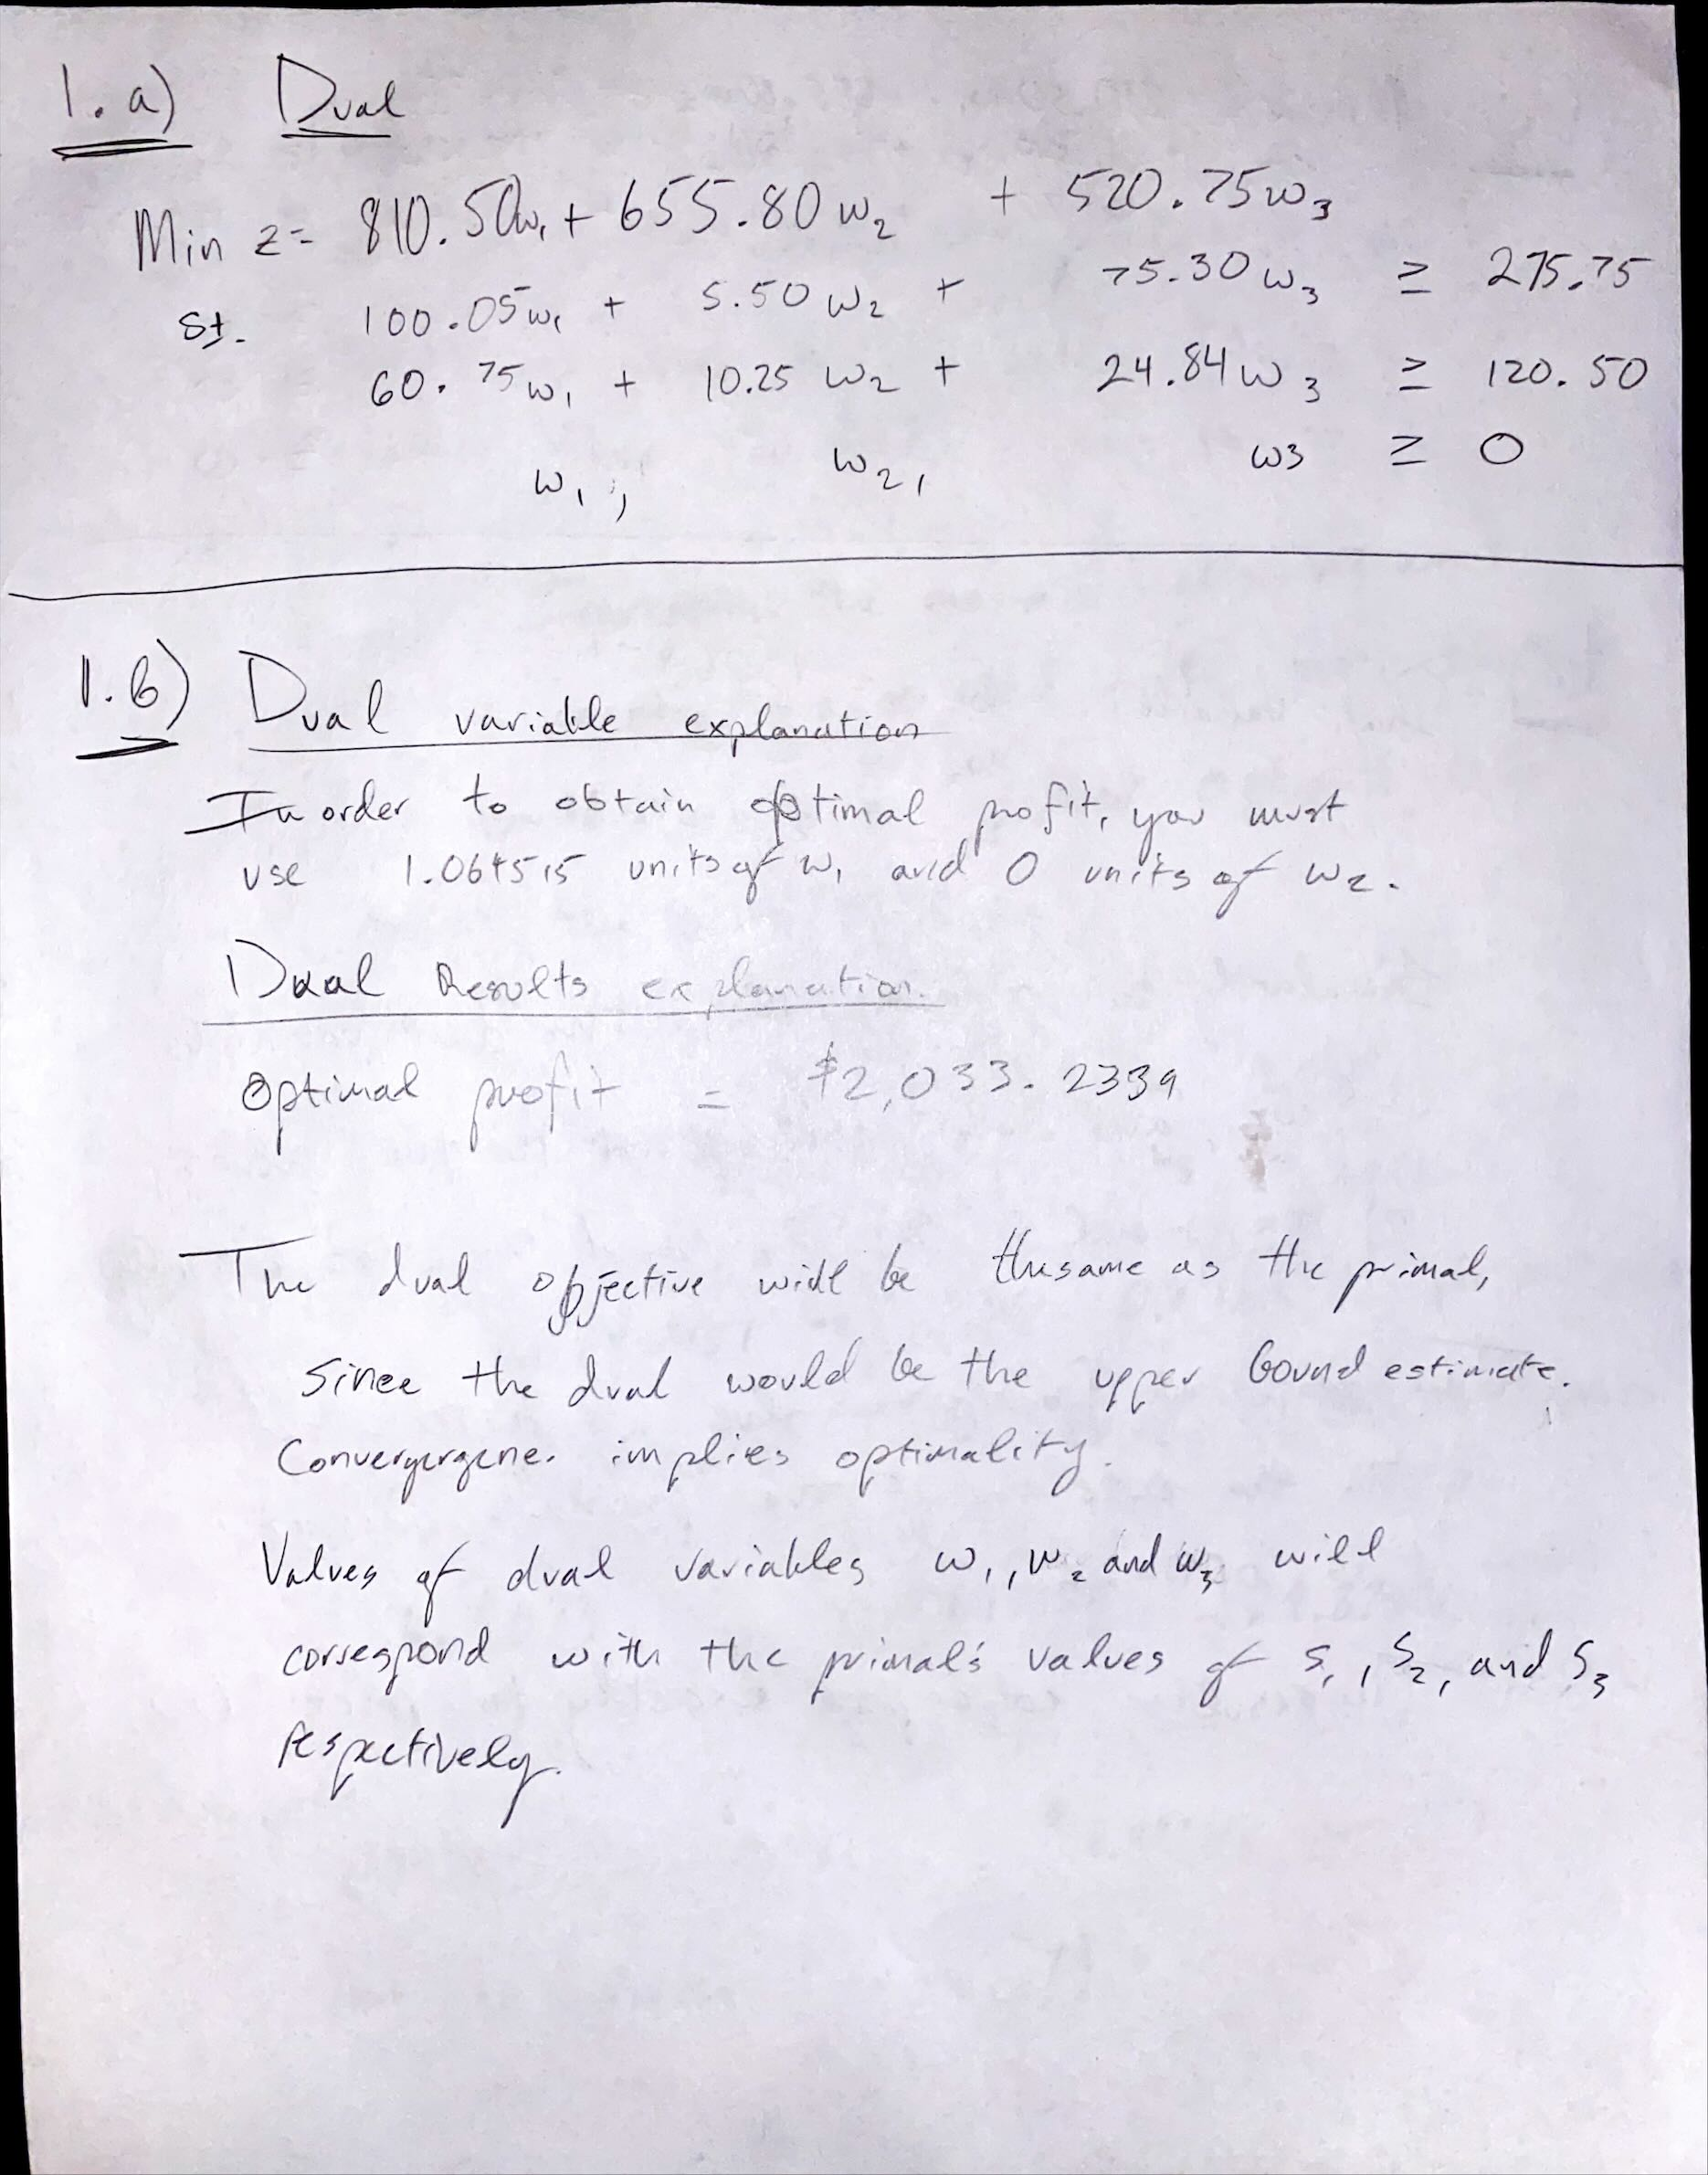

***(Python code on next page)***

**Snapshot of Problem 1 (b):**

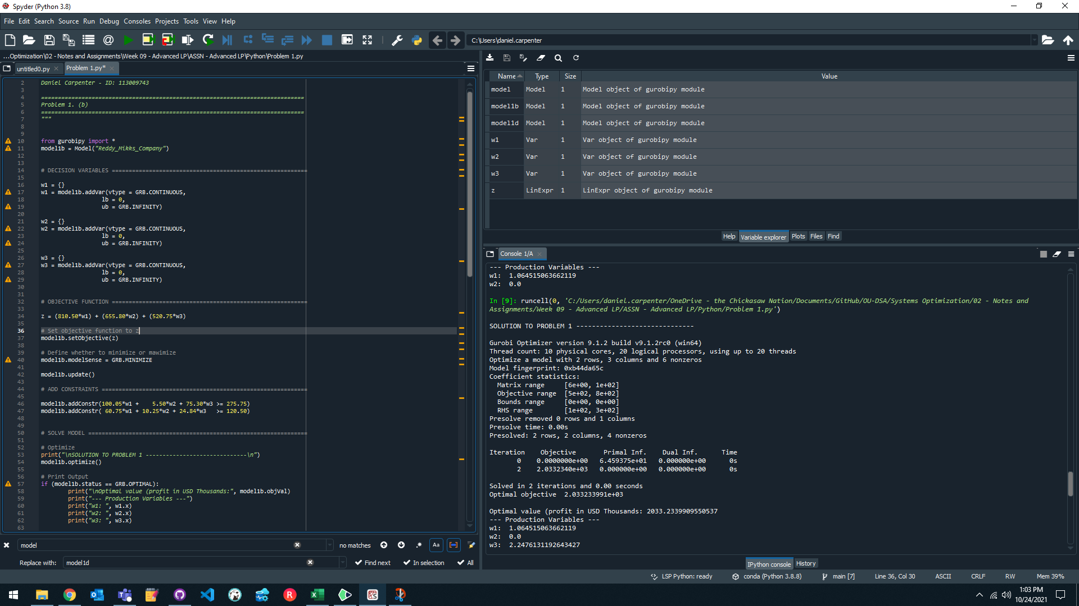

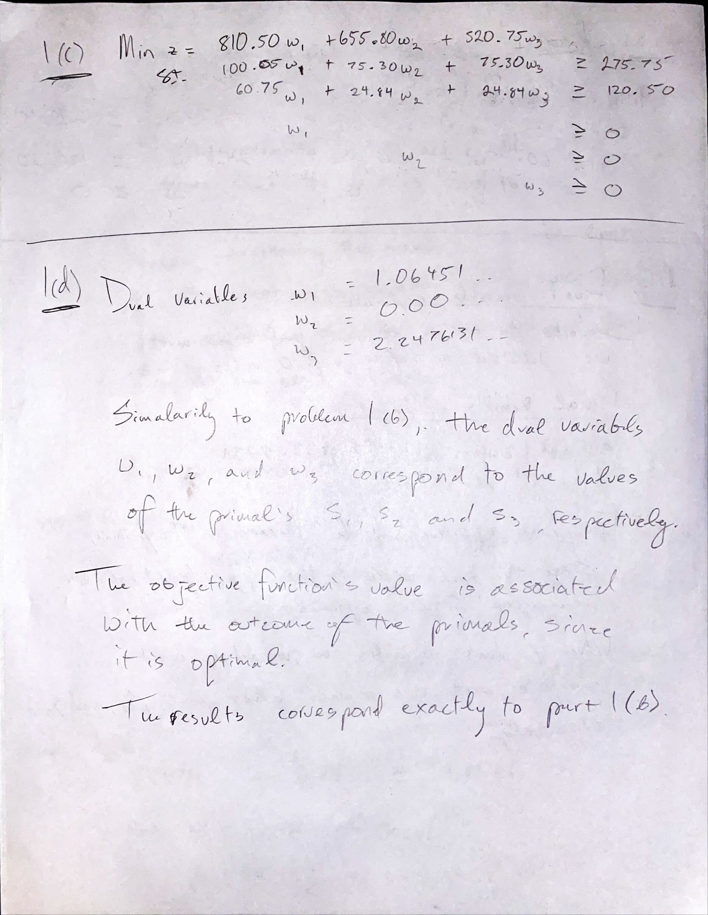

**Snapshot of Problem 1 (d):**

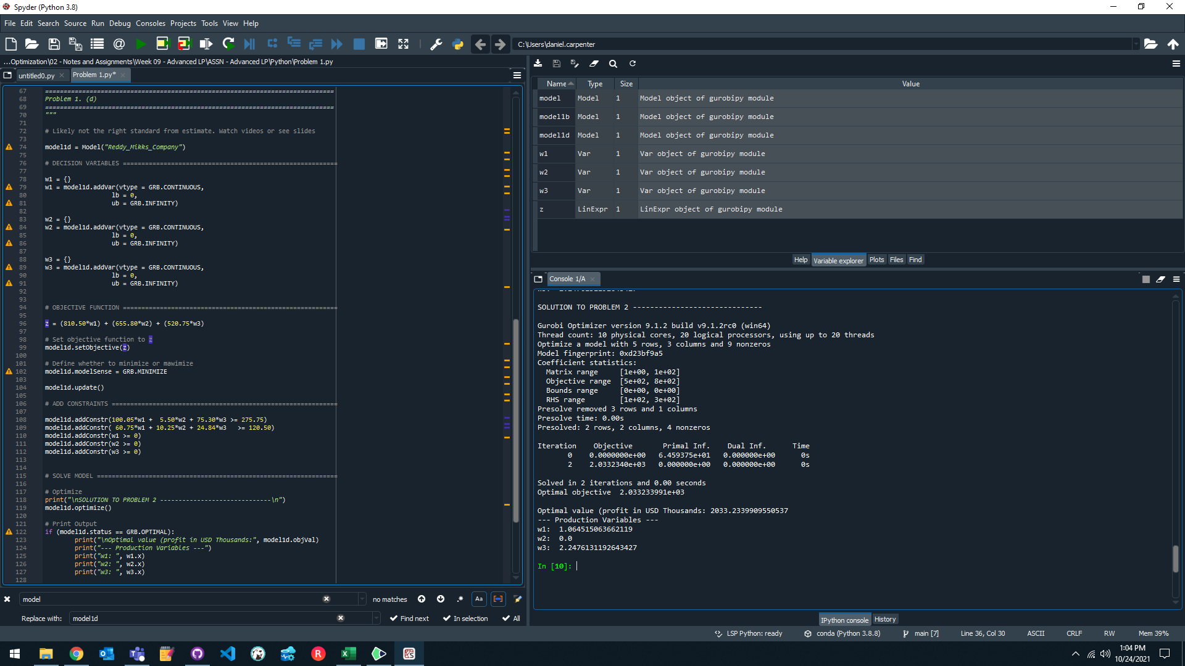

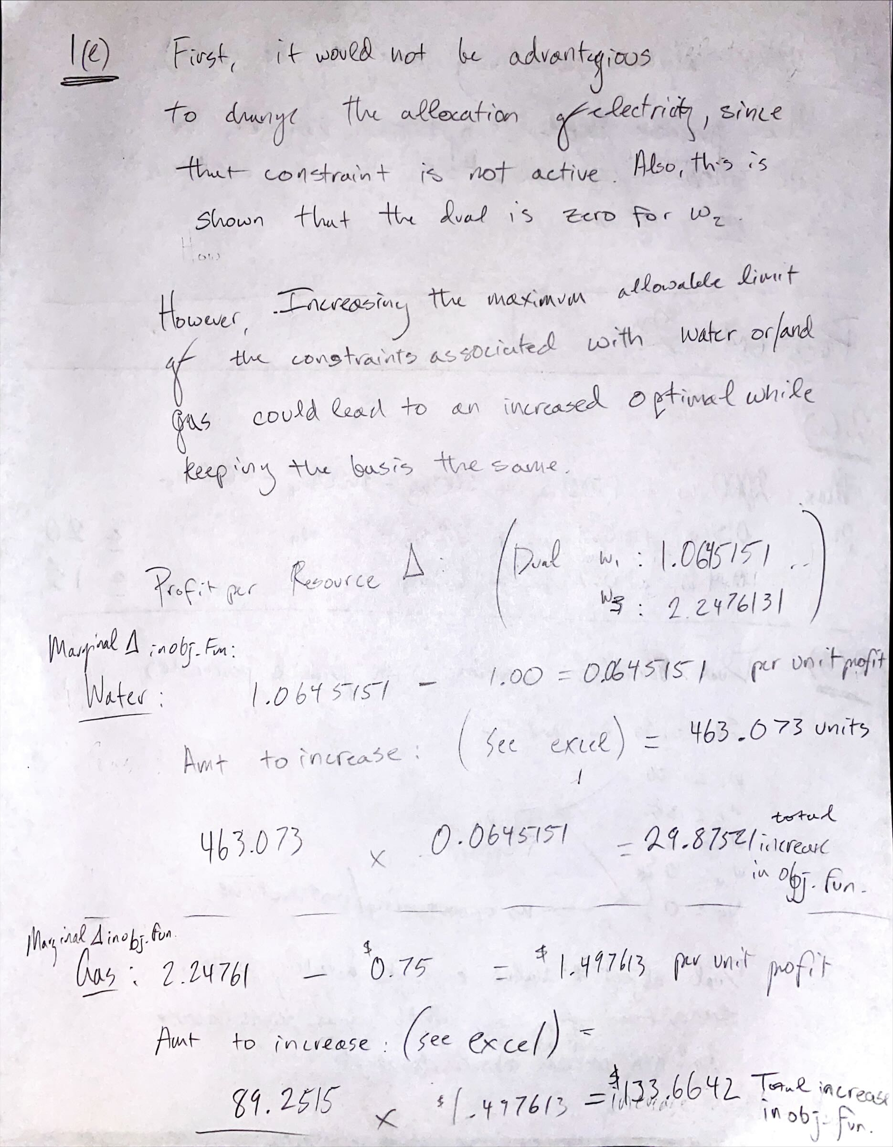

**Snapshot of Problem 1 (e):** (*Please see Excel file for all calculations*)

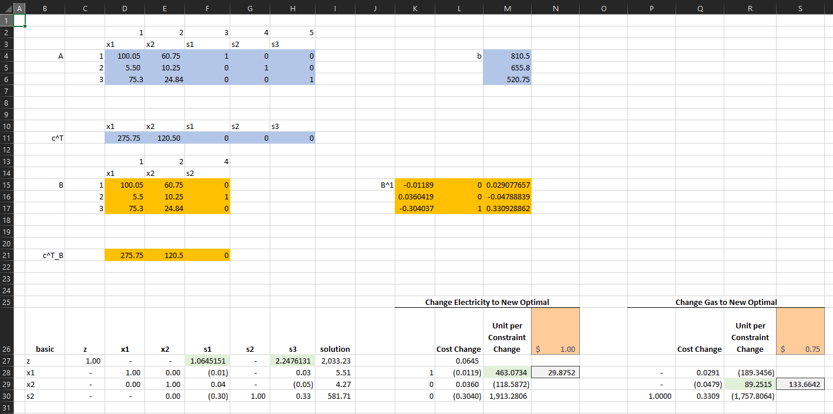

**Snapshot of Problem 1 (f):** (*Please see Excel file for all calculations*)

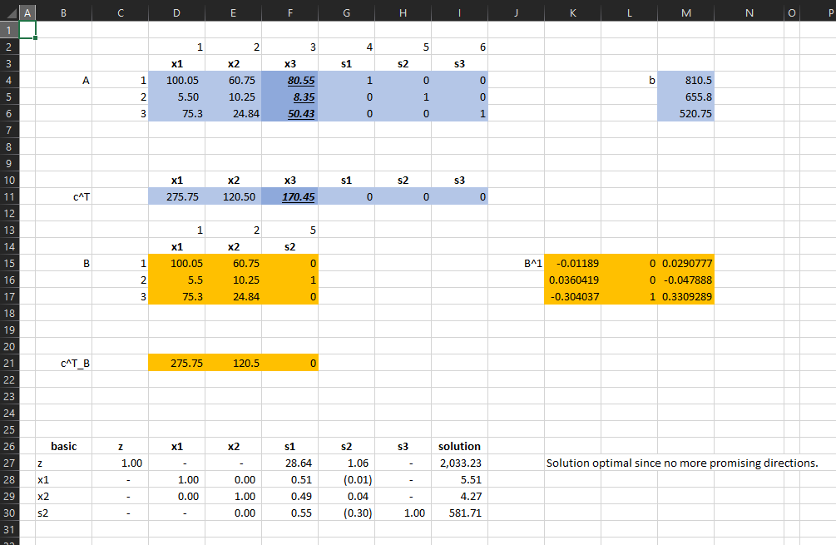

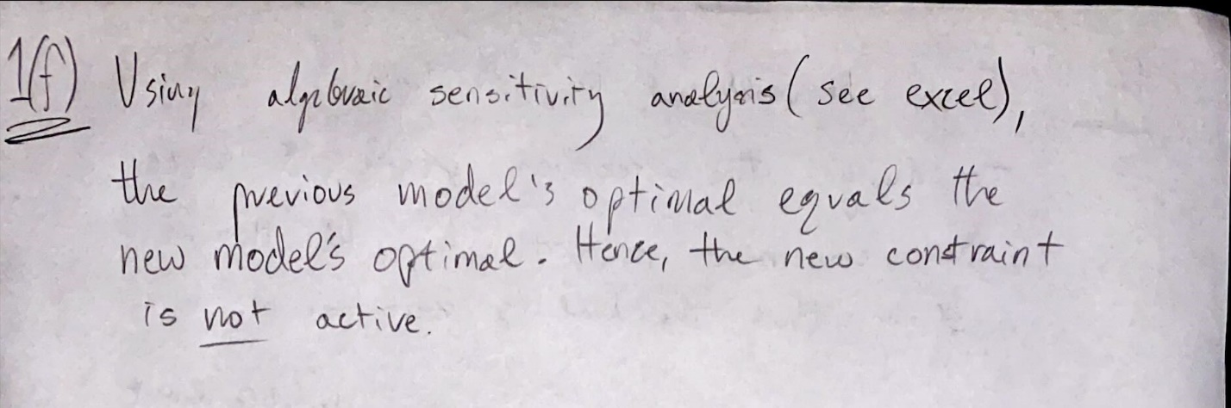

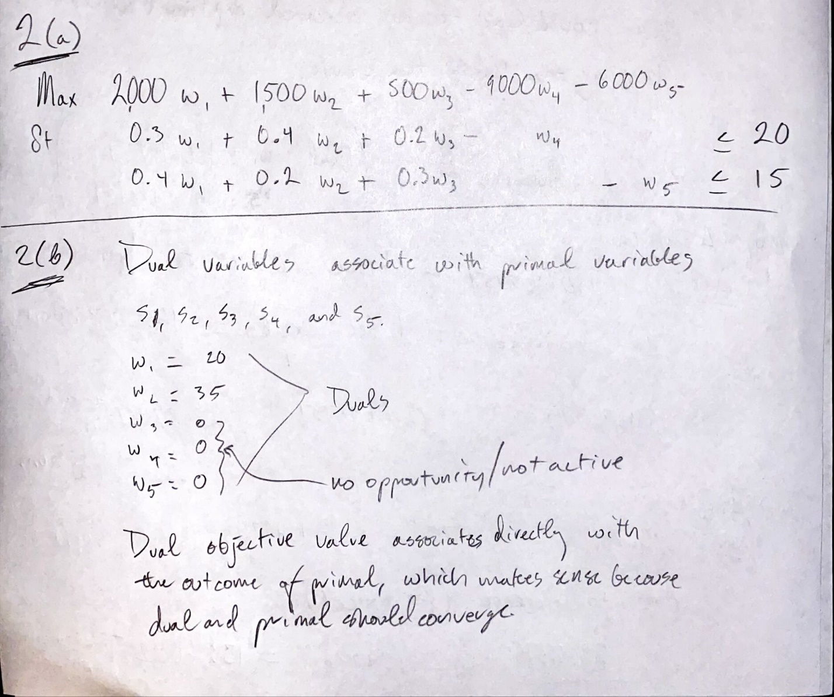

**Snapshot of Problem 2 (b):** (*Please see Excel file for all calculations*)

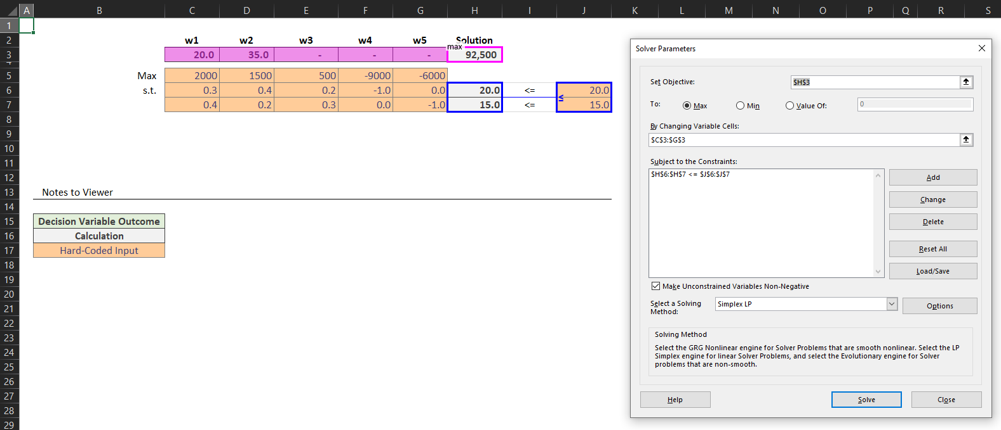

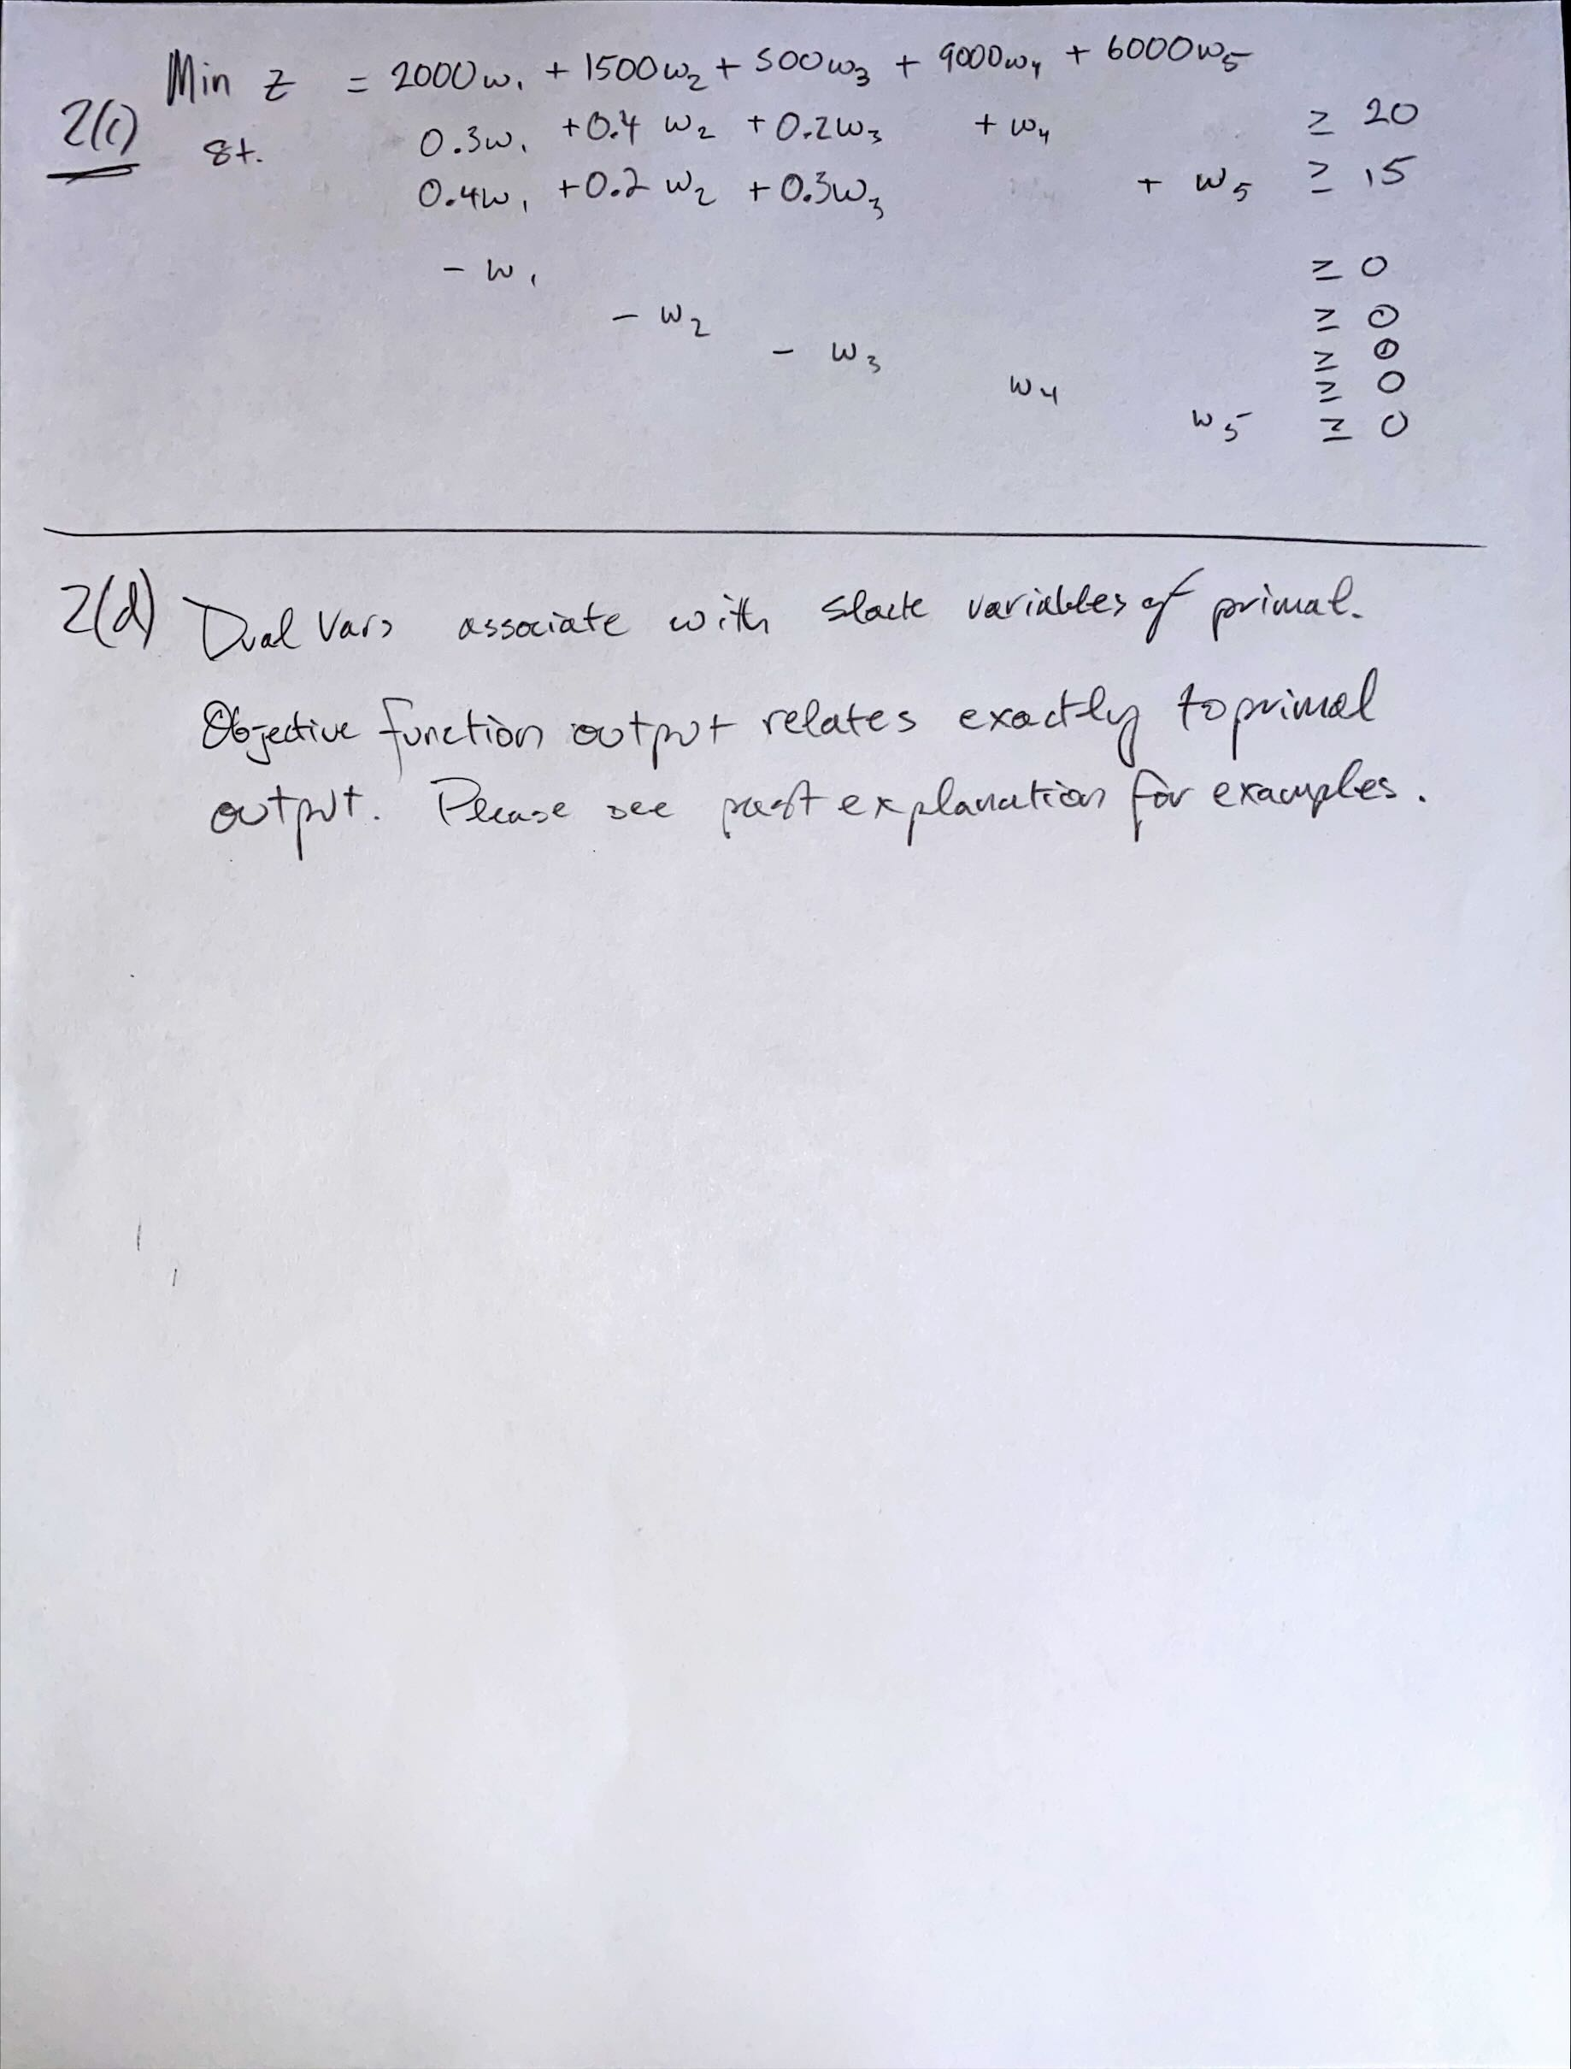

**Snapshot of Problem 2 (d):** (*Please see Excel file for all calculations*)

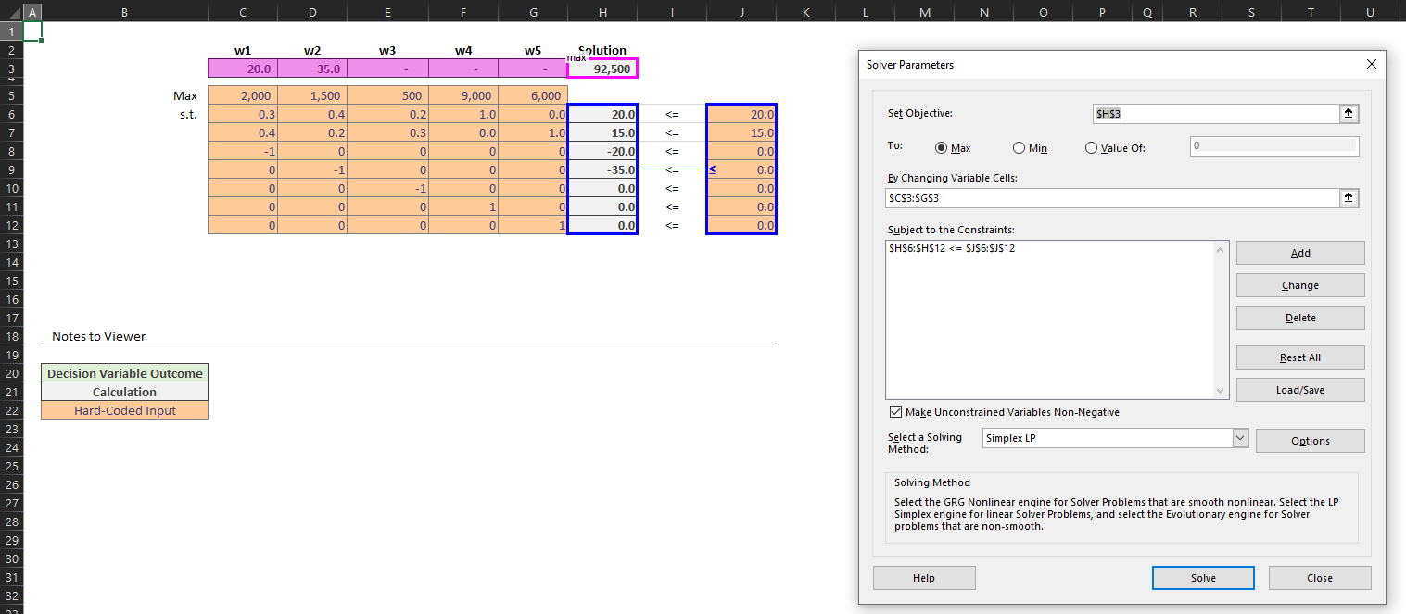

**Snapshot of Problem 2 (e):** (*Please see Excel file for all calculations*)

1. While keeping the supply fixed and the basis the same for optimality, the range of prices are the following:
   * 1. High Price: Saudi: **$30.00**, and Venezuela:$15.00, total cost: **$112,500.00**
     2. 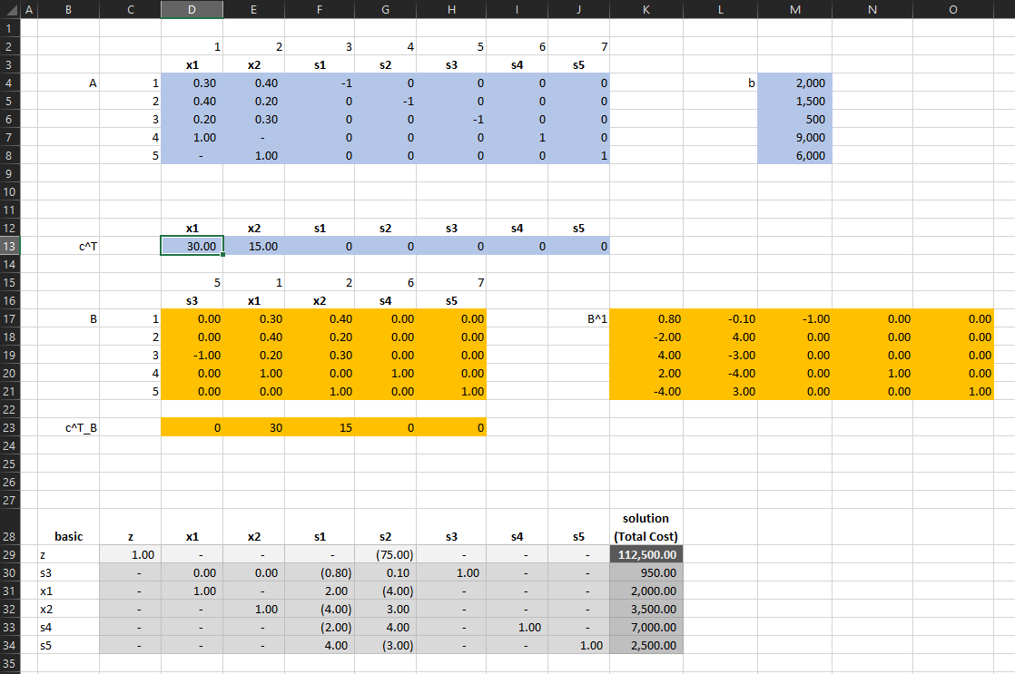
     3. Low Price: Saudi: **$11.25**, and Venezuela: $15.00, total cost: **$75,000.00**
     4. 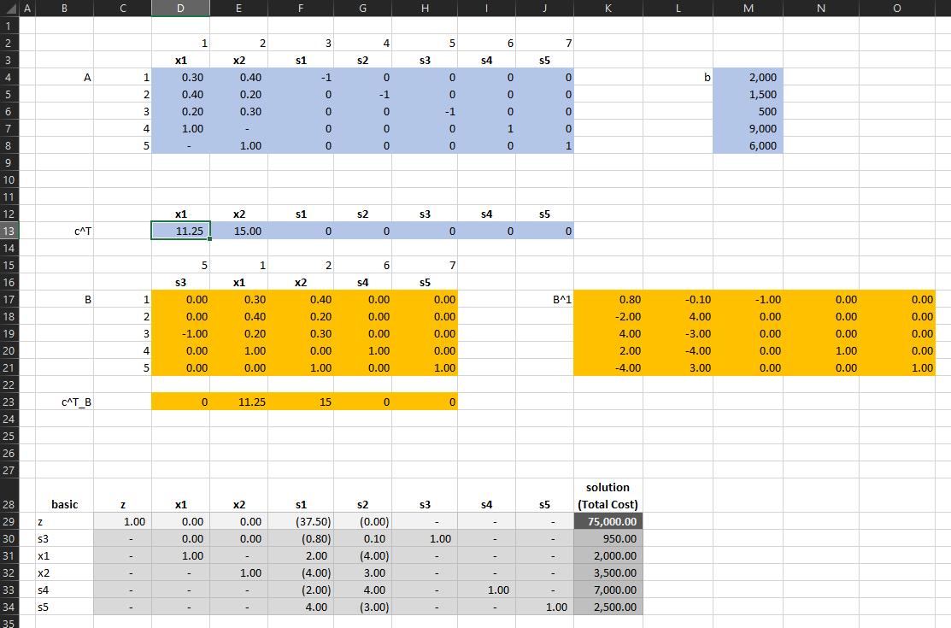

**Snapshot of Problem 2 (f):** (*Please see Excel file for all calculations*)

1. While keeping the supply fixed and the basis the same for optimality, the range of prices are the following:
   1. High Price: Saudi: $20.00, and Venezuela: **$26.67**, total cost: **$133,333.33**
   2. 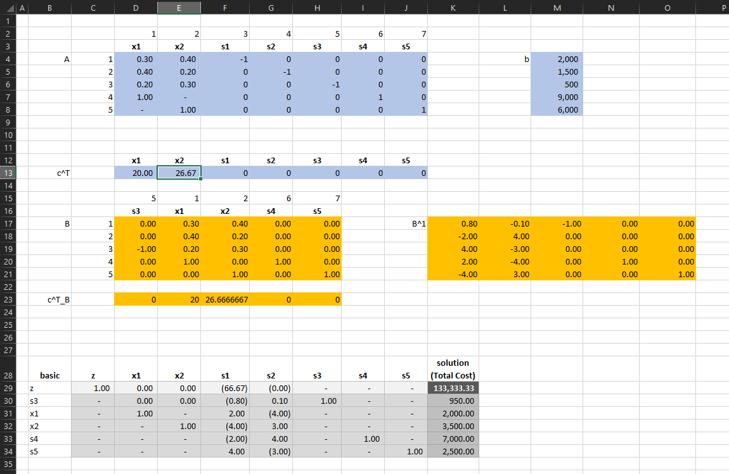
   3. Low Price: Saudi: $20.00, and Venezuela: **$10.00**, total cost: **$75,000.00**
   4. 